Activity 28

NAME : Rose Mystica. J COURSE : Mobile Computing
Reg No : 192421410 COURSE CODE: ITA0302

Design a wireframe in Figma for a mobile application showcasing power management Approaches.

Aim:
Design a wireframe in Figma for a mobile application showcasing power management Approaches.

Procedure:
- Create a file
- Add The First Frame
- Add Shapes
- Add Text
- Create The Second Frame
- Add Prototyping

Step By Step Procedure :

Interface Of Experiment
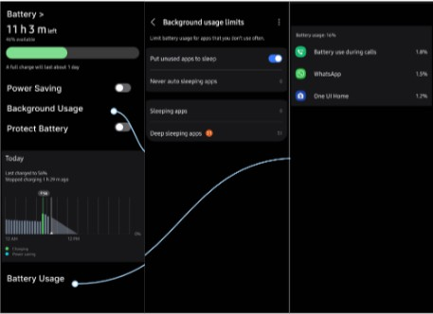

Prototype:

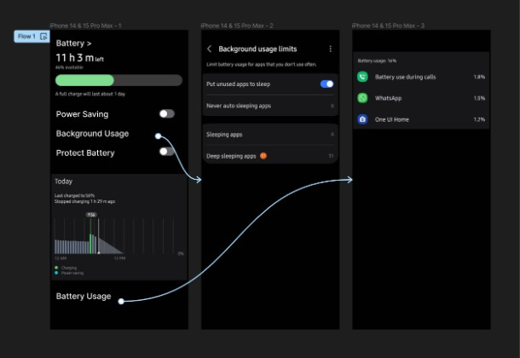

Result:
Hence the mobile application showcasing power management is created and executed successfully.

